 | Desynit Limited  City Point  Temple Gate  Bristol  BS1 6PL  Tel +44 117 373 6791  Fax +44 117 373 6787  enquiries@desynit.com  www.desynit.com
To: <ToName> | From: <FromName>
Fax No: <ToFax> | Email: <FromEmail>
Date: <Date> | Phone: <FromVoice>

Subject: Policy expiring soon - <Subject>

Dear Supplier,

The following policy is about to expire. Please log into the customer portal to mark these cases as paid, or get in touch via one of the contact methods above.

Name | Order Number | Amount | Expiry Date
<ToUser1> | <Subject> | <ToUser2> | <ToUser3>

Policy Description: <Message>

Yours Faithfully,

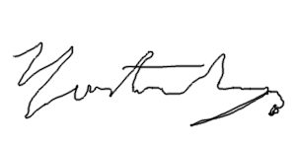
Christopher Alun Lewis
Policy Renewals Clerk

